Girl Scouts of the USA is a community service organization dedicated to building girls of courage, confidence, and character who make the world a better place. Through hands-on service projects, Girl Scouts learn the value of helping others, addressing real needs in their communities, and becoming compassionate, responsible citizens.
Community service is important because it teaches empathy, teamwork, and leadership while fostering a sense of belonging and purpose. By giving their time and energy to support others, Girl Scouts not only strengthen their communities but also grow personally—developing lifelong skills and a lasting commitment to making a positive difference.
All Girl Scouts, regardless of level, are encouraged to participate in community service projects as part of their journey to make the world a better place. For younger Girl Scouts—Daisies, Brownies, and Juniors—community service often takes shape through Take Action projects or community-based badges that teach the value of helping others.
Examples include the Daisy Good Neighbor badge, which introduces girls to being caring and helpful members of their community, and the Brownie Celebrating Community badge, which helps them learn about their local community and how they can contribute to it.
For older Girl Scouts—Cadettes, Seniors, and Ambassadors—community service continues to be an essential part of their experience through more advanced Take Action projects and opportunities to earn the Girl Scout Community Service Bar and Service to Girl Scouts Bar. These awards recognize their dedication to serving others and supporting the Girl Scout movement, encouraging leadership, responsibility, and a deeper connection to their communities.
Please see the Community Service Opportunities section below for organizations that may provide community service opportunities for your Girl Scout.

Community Service Bars
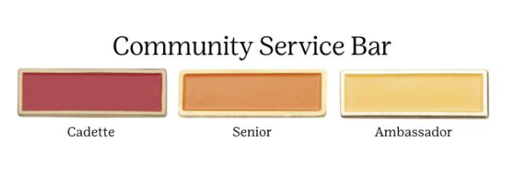
Cadettes, Seniors, and Ambassadors can earn a Community Service Bar at each level by completing 20 hours of community service. These hours must be solely dedicated to community service and cannot be applied toward other Leadership or Mentoring awards such as High Award projects or Torches.
Girl Scouts will use the attached Community Service Hours Form to track their service activities. Once all 20 hours are completed, the form should be submitted to the Troop Leader, who will then deliver it to Council to verify the hours and purchase the earned pin.

Service to Girl Scouts Bars
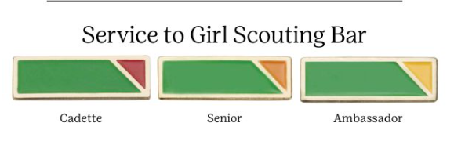
Cadettes, Seniors, and Ambassadors can earn a Service to Girl Scouts Bar at each level by completing 20 hours of service to the Girl Scout organization. This service can include:
- Mentoring younger Girl Scouts in a troop (outside of normal troop activities)
- Volunteering at a Service Unit or Council-led event
- Assisting at the local Council office
Girl Scouts will use the attached Community Service Hours Form to track their service hours. Once all 20 hours are completed, the form should be submitted to the Troop Leader for approval. The Troop Leader will then deliver it to Council, who will verify the hours and purchase the earned pin.

Community Service Opportunities
Please click here for links to organizations that regularly offer community service opportunities. This list is not comprehensive and does not represent the only places where Girl Scouts may volunteer.
Before participating, a Girl Scout should verify with her caregiver or Troop Leader that the organization and activity meet Girl Scout guidelines and Safety Activity Checkpoints.
Please note that these organizations are third parties not directly affiliated with Girl Scouts of Southern Nevada, and we cannot guarantee the availability of opportunities or acceptance of a Girl Scout’s participation in any activity.

